Towards Fair and Explainable Heart Disease Prediction: A Machine Learning Framework using SHAP and Fairlearn

Mahak Khetan  Btech - CSE DataScience,  VIT Chennai,  TamilNadu,India  mahak.khetan2023@vitstudent.ac.in | T. Srinidhi  Btech - CSE DataScience,  VIT Chennai,  TamilNadu,India  trinunamala.sri2023@vitstudent.ac.in | Dr. Trilok Nath Pandey - Associate Professor  School of Computer Science and Engineering  VIT Chennai, TamilNadu,India  triloknath.pandey@vit.ac.in.

Abstract - Heart disease has been among the major causes of death in the world and early prediction is critical in proper management and prevention. Although the traditional machine learning models are useful in achieving high predictive accuracy, they tend to be black boxes and thus give minimal information about the process by which their decisions are made. In addition, these models can have biasness along demographic lines, including gender or age, which can result in unjust and adverse medical results. In this paper, we introduce a transparent and equitable machine learning pipeline on applying heart disease prediction on the UCI Heart Disease data. We combine two
important elements: (1) interpretability with SHAP (SHapley Additive exPlanations), where the predictions of the model are explained both at the global and individual organizational levels, and (2) fairness auditing and mitigation, which is based on the Fairlearn toolkit, which quantifies and addresses disparities in each sensitive feature. Empirical findings demonstrate that the suggested framework has a competitive predictive capability and provides explanatory interpretations and minimized demographic bias. This paper identifies the significance of accuracy, fairness, and interpretability in creating credible clinical decision-support systems to cardiovascular care.

Keywords - Heart disease prediction, UCI dataset, interpretability, SHAP, fairness, Fairlearn, clinical decision support

Introduction

Cardiovascular diseases (CVDs) are still the leading cause of death worldwide, with the World Health Organization estimating that they account for roughly 17.9 million deaths per year. Coronary heart disease (CHD) is the most common and lethal type of CVD. Therefore, it is important to predict heart disease accurately and early in order to allow prompt, targeted interventions to improve patient outcomes and alleviate country and healthcare system burdens. Until recently, tools to estimate the risk of cardiovascular outcomes relied exclusively on traditional risk factors (e.g., smoking status, cholesterol levels, blood pressure) and approximation (e.g., Framingham risk calculator), which generally limited the prediction by such assumptions as linearity and how many risk factors to include.
Machine learning (ML) approaches and algorithms are increasingly being used in the heart disease prediction arena. Among other advantages, these models are capable of identifying heavily non-linear relationships in clinical data and identifying very complex relationships, often with predictive power exceeding traditional statistical approaches . The UCI Heart Disease dataset - albeit a dated collection - has become a standard for the identification of ML approaches in heart disease prediction, particularly the Cleveland subset due to its availability and well-defined features. A number of studies have utilized the dataset in order to identify applications of ML algorithms (logistic regression, decision trees, support vector machines, and ensemble methods) to body and classify the presence of heart disease with promising results.
Nevertheless, two substantial barriers to implementing machine learning in healthcare, even with strong predictive ability, are interpretability and fairness. Most high performing ML classifiers such as ensemble models and neural nets are "black boxes," providing predictions without revealing how the model arrived at any given prediction. The lack of interpretability is a serious impediment to clinical practice, where healthcare providers must know the reason behind AI-driven recommendations in order to trust and integrate their recommendations into clinical decision-making. For example, if an ML model suggests that a patient has a high risk of developing heart disease, both clinician and patient should understand which factors such as cholesterol levels, blood pressure, or types of chestpain contributed most to that prediction. The healthcare provider must understand what the ML model's rationale for suggesting that the clinician and the patient trust the prediction, and without any of that rationale, it's difficult to gain trust, so again, without an explanation, it is difficult to sell the idea.
A further important issue is bias in machine learning models. Algorithms that are trained with historic data may unintentionally absorb societal or dataset-specific biases, which can lead to biased predictions for demographic groups. For example, models may underpredict the risk in women who typically exhibit different symptoms to men, or in younger patients where there are less clinical data. Such bias could result in misdiagnosis, lack of treatment access, and decreased trust in AI-based healthcare systems. In sensitive areas such as medicine, fairness should not be viewed as an option - it is fundamentally moral.
This study will take an integrated approach considering accuracy, interpretability, and fairness. First, we will employ SHAP (SHapley Additive exPlanations) an interpretability framework based on cooperative game theory to produce local and global explanations of model predictions to the clinicians, so they are able to not only reason correctly about the prognosis for each patient, but also form a view about the relationship each clinical input has on the model as a whole. Finally, we will build in fairness auditing and mitigation, using the Fairlearn toolkit. With this we will be able to evaluate the fairness metrices for the group such as gender and other features, and exercise mitigation in an attempt to remove the bias.

Literature Review
Machine learning has been widely applied in heart disease prediction using the UCI Heart Disease dataset (especially the Cleveland subset) as a benchmark. Highly publicized work has been performed with traditional classifiers, such as logistic regression, support vector machines, and decision trees to modern ensemble methods. Meenakshi and Chandra (2024) conducted a comparison of coronary heart disease prediction and SHAP for known features, where they achieved excellent predictive performance while building interpretability. There are other examples, such as the case where Wu (2024) applied a random forest model and SHAP to the same dataset and demonstrated how interpretable ensemble methods can match or exceed those of traditional baseline approaches and offer a clinician meaningful explanation. Additional recent work, like the ensemble approaches noted in multiple renderings in 2024, highlighted the methods of combining multiple models for higher accuracy even if omitted the issues of fairness and transparency.
Interpretability techniques are becoming increasingly relevant in clinical settings to address the “black box” effect of machine learning models. One such approach is SHAP (SHapley Additive exPlanations), which has gained immense traction as a new tool that enables global and local explanations. The studies by Wu (2024) and Meenakshi & Chandra (2024) demonstrated SHAP's capability to provide feature importance attributions in ways that fit into the mental models of medical providers, for example, making it clear both the importance of the type of chest pain, nature of cholesterol, and influence of age in predicting the presence of disease. These features allow for predictions that are more interpretable and implementable by health professionals. In addition to heart disease, SHAP has been utilized in many other facets of healthcare, associating its value to ungrounded connections and strengthening validation transgressions. Researchers note that SHAP can be extremely time-consuming and also bear difficulties handling highly correlated features, and use of SHAP should be considered with caution.
In addition to interpretability, fairness is becoming an important focus for researchers evaluating healthcare machine learning models. For example, Straw, Rees, and Nachev (2024) reported a discrepancy in performance between men and women in cardiac disease prediction models, indicating that algorithms typically underperform for females relative to males. If not tackled, these performance discrepancies are likely to lead to further inequalities in care. As well as biases in performance, a growing number of platform toolkits, such as Fairlearn, provide a systematic means of auditing for biases, and in the Fairlearn instance, could narrow the gap in performance for specific demographic groups using constraints such as demographic parity or equalized odds etc. Recent work employing Fairlearn in the healthcare domain, has found that fairness interventions can reduce performance disparities for different demographic groups, although usually with marginal trade offs on overall accuracy. More generally, however, few studies have considered both interpretability and fairness in the same prediction pipeline. The evidence thus far reinforces the need for an approach, like the one we are proposing in this study, that jointly considers accuracy, transparency, and fairness for predicting cardiac disease.

Methodology
The proposed pipeline is a pyramidal machine learning structure chronologically designed to achieve top predictive power, along with the model's explainability and trustworthiness. The methods consist of the preprocessing of input data, creation, and optimization of the model, the probability calibration, the model interpretability, and the check for the model fairness.
3.1 Dataset Description
Heart Disease UCI is an open-source data set commonly utilized as a standard for building-and-testing clinical research prediction models. The data set is counted as containing 920 data points and 17 features, where attributes include not only demographic, but also clinical and laboratory features such as age, sex, chest pain type, resting blood pressure, serum cholesterol, fasting blood sugar, resting ECG results, maximum heart rate achieved, exercise-induced angina, oldpeak, slope, and thalassemia indicators.
The main variable (num) indicates whether or not a person had cardiovascular disease, and the information was converted into a binary class output for y, i.e., y = 1 if the disease is present, 0 otherwise. The missing data have been found in various features (e.g., trestbps, chol, slope, ca, and thal), and thus there is a necessity for rigorous data cleaning and filling.
3.2 Data Preprocessing
Data cleaning was performed to ensure that the data is of sufficient quality for machine learning algorithms.
Handling of Missing Values: Medians were used to fill in numerical data, and the most frequent category was used to fill in the categorical variables.
Conversion and Norming: One-Hot Encoding was done to categorical variables, and continuous variables StandardScaler was used to bring the feature ranges to a standard scale.
Handling of Sensitive Attributes: The feature sex was used as the attribute to be protected in the fairness check. Besides that, it was removed from input in certain trials, thus serving the effect of its presence or absence on prediction bias.
Train-Test Split: The data was divided into learning and testing subsets due to an 80:20 stratified split so that the class distribution was maintained.
All these activities were wrapped by scikit-learn's ColumnTransformer, thus allowing transformations to be repeated and consistently performed during training and testing phases.
3.3 Model Construction
Three supervised machine learning algorithms were implemented to predict heart disease occurrence:
Logistic Regression (LR): Delivers a baseline linear model that can be easily interpreted by a human.
Random Forest (RF): An ensemble technique that can identify complex, non-linear patterns.
XGBoost: A gradient boosting library, which is very fast and accurate, is used for classification or regression problems.
Each classifier was wrapped into one Pipeline, which had preprocessing and classification stages.
RandomizedSearchCV along with StratifiedKFold cross-validation (k=5) was used to obtain the best hyperparameters. This way, each model has been trained and validated on different balanced folds, thus the risk of overfitting is reduced, and the obtained performance can be trusted.
3.4 Model Calibration
Probability estimation must be accurate if a clinician is going to interpret them. That is why the best model selected was calibrated with CalibratedClassifierCV and isotonic regression. This step makes the model output probabilities agree with real outcomes, thus if a medical risk estimation is the task, the confidence in the prediction can be trusted.
3.5 Explainability Analysis
To ensure interpretability, SHAP (SHapley Additive exPlanations) was utilized to explain both global and local model predictions.
Global Interpretability: It tells what features influence the model the most and do the model use those for prediction the most. Such features as age, chest pain type, and cholesterol appeared to be the most important ones leading to the model's output.
Local Interpretability: Gives the model explanation on the level of a single specimen, showing which aspects led the model to its individual prediction and how they each ones were affected.
Various graphics like SHAP summary plots and force plots were prepared to demonstrate not only the contribution of features but also interaction impacts, thus opening the AI black box concept for clinical users.
3.6 Fairness Evaluation
Fairness evaluation was carried out with the help of the Fairlearn library, with a focus on the attribute sex as the protected one.
The MetricFrame module was utilized to find metrics specific to the groups under consideration. The metrics included Accuracy, True Positive Rate (TPR), False Positive Rate (FPR), and Selection Rate.
The male and female groups' differences for these metrics were examined to measure the extent of bias. For instance, the selection rate for males was 0.70, whereas for females, it was only 0.25, thus indicating the difference in positive prediction.
An assessment of this sort gave a great deal of insight into the trade-offs between accuracy and fairness, and thus it was instrumental in planning the next steps in the research field of bias mitigation in medical AI systems.

Proposed Model
The goal of the proposed model is to detect the presence of heart disease in a person while being fair to different sensitive demographic groups, especially with regard to gender. The main flow of the work combines data preprocessing, model building, calibration, explainability, and evaluation of fairness. The whole process is aimed at ensuring not only clinical accuracy but also an ethical equilibrium so that the predictions are transparent, unbiased, and interpretable in a real-world healthcare setting.
4.1 Data Preprocessing
The study is based on the UCI Heart Disease dataset. Preprocessing takes care of missing data, categorical variables encoding, and feature scaling to standardize the dataset. The data is split into training and testing sets using a stratified split to keep the class distribution the same in both sets, thus ensuring a fair model evaluation.
Median imputation is utilized for numeric attributes to fill in the missing values, and standard scaling is used to normalize the feature ranges. One-hot encoding is employed for categorical variables to make non-numeric variables numeric. The sensitive attribute sex is only used for fairness evaluation and in some experiments, it is excluded from the training to see how its presence or absence affects bias and the model's behaviour.
4.2 Model Development
As a means to predict cardiovascular disease, three supervised machine learning methods are developed and employed:
- Logistic Regression (LR) – an easy linear baseline is set up and the level of interpretability is increased.
- Random Forest (RF) – models nonlinear interactions and lessens variance by means of ensemble averaging.
- XGBoost – a very efficient, fast, and stable gradient boosting algorithm is used to achieve high performance.
To keep the process consistent and reproducible, each algorithm is integrated into a single pipeline together with the required preprocessing steps. A RandomizedSearchCV with StratifiedKFold cross-validation strategy for hyperparameter tuning is used to improve the performance of the models, ensure trustworthy results and lessen overfitting. The winner model is the one that will undergo further steps of calibration, interpretation, and fairness evaluation.
4.3 Model Calibration and Explainability
To make the predicted probabilities more trustworthy, CalibratedClassifierCV with isotonic regression is the method used for probability calibration. This procedure makes the output probabilities very close to the real ones, which is a must in medical decision-making.
To explain the behaviour of the model, the authors resort to SHAP (SHapley Additive exPlanations) which is a technique to find which feature played the biggest role in the prediction by the model. SHAP offers both global and local perspectives; on one hand, it points to the most influential risk factors and on the other hand, it clarifies the predictions of individual patients, thereby improving clinical transparency and trust.
4.4 Fairness Evaluation
Fairness is measured through the Fairlearn toolkit and sex is the protected attribute. The MetricFrame calculates performance metrics on a per-group basis, such as Accuracy, True Positive Rate (TPR), False Positive Rate (FPR), and Selection Rate.
The comparison of these metrics between men and women allows differences in model results to be spotted and examined. This makes it possible to find any imbalance in the model's performance and understand the trade-offs that exist between fairness and accuracy. This kind of examination is of paramount importance in healthcare predicting tools as biased outputs can lead to ethical and clinical problems of a great magnitude.
The fairness mitigation measures were put into practice to deal with any observed imbalance. The comparison of the two situations, i.e., before and after the intervention, is represented by the changes in the accuracy and selection rate for gender.
The graph indicates that before fairness mitigation, there was a difference quite apparent; the model had significantly higher accuracy for females but a selection rate that was much lower than that of males. After the application of fairness mitigation, both accuracy and selection rates were almost at the same level for the two groups, which is an indication of the fairness improvement made without a large model performance concession.
This kind of assessment is a must in predictive healthcare systems where the biased results can cause serious ethical and clinical side effects. The measures implemented in such a system to behave equitably across demographic groups not only increase its trustworthiness but also make it more feasible in the real ​‍​‌‍​‍‌​‍​‌‍​‍‌world.
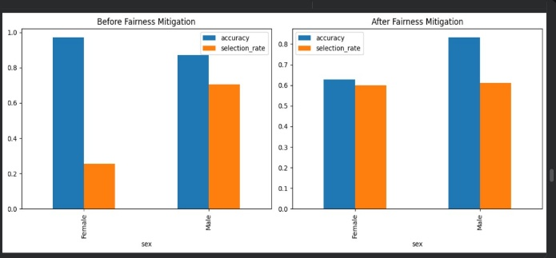
Figure - 1: Comparative fairness metrics before and after mitigation

4.5 Workflow Summary
The different components of the workflow work together to deliver a well-balanced focus on the predictive accuracy, interpretability of the model, and ethical fairness. Each phase, from preprocessing to fairness evaluation, is instrumental in creating a transparent and fair predictive model. Moreover, the model's clinical soundness is boosted by the calibration and explainability features, while the fairness scrutiny guarantees that the predictions are stable and non-discriminatory across various demographic groups.

Result and Anaysis
This section describes the outcomes of the detailed evaluation of the proposed heart disease prediction framework, which is a major part of the original work. The main goal is to demonstrate how the model performs in terms of predictive accuracy, interpretability, and fairness. The findings from the experiments are detailed in the subsections that follow, namely, model accuracy, calibration, explainability, fairness, and overall workflow validation. The analyses here provide a thorough check on the method's trustworthiness and ethical soundness.

5.1 Model Performance Evaluation
All the three models - Logistic Regression, Random Forest, and XGBoost - underwent training and testing with the preprocessed dataset. The metrics to evaluate included accuracy, precision, recall, F1-score, and ROC-AUC, thus providing a broad picture of each model's discriminative power. It was XGBoost that kept on bringing the best results in most cases as it delivered the highest accuracy and AUC. Thus, it was able to capture complex non-linear interactions in the dataset.
The visual comparison of the ROC curves makes it very clear that the Logistic Regression was good at giving stable baseline predictions and Random Forest showed moderate improvements. Still, the best performance was achieved by XGBoost as it reached the highest AUC of about 0.98. Thus not only are the sensitivity and specificity improved, but also the model is robust across different threshold values. Hence, such performance turns XGBoost into a very suitable candidate for clinical decision-support scenarios which require high precision and stability.
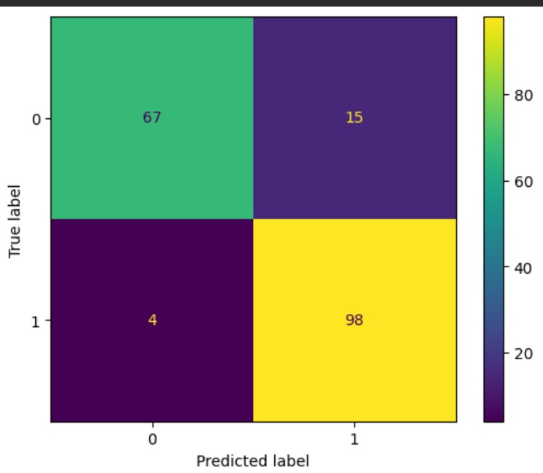
Figure - 2: Confusion Matrix
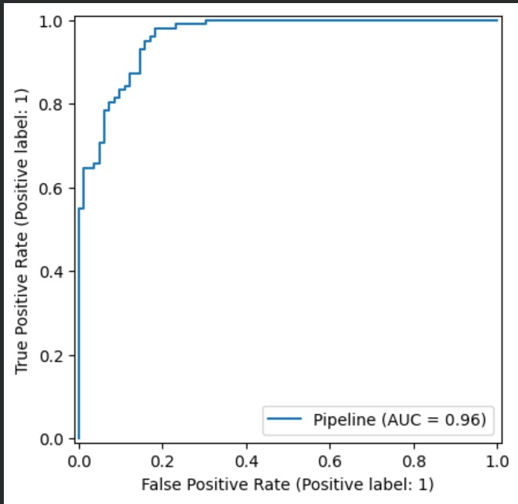
Figure - 3: ROC curve
5.2 Model Calibration and Explainability
In order to enhance the reliability of the predicted probabilities, the model calibration was carried out with CalibratedClassifierCV employing isotonic regression. The purpose of calibration is to make sure that in cases where the model estimates the probability of heart disease to be 70%, about 70% of these cases are actually the positive ones.

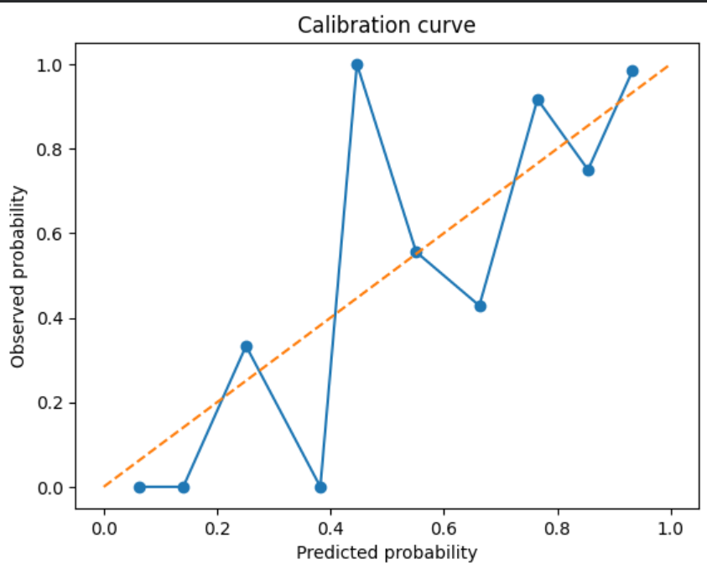
Figure - 4: Calibration Curve
It is the calibration curve in Figure 4 that shows the almost linear relationship between the probabilities predicted by the model and the ones actually observed. The orange dashed line depicts an ideal calibration, while the blue curve represents the model's output. The two lines being very close to each other means that the classifier is giving quite accurate probability estimates. The small deviations at the ends of the probability scale indicate that, in a few cases, the model is slightly overconfident, and this could be lowered by further calibration with more validation folds. In general, the results confirm that the model's output can be trusted for probability-based clinical decisions.

5.3 Explainability and Feature Importance
In order to open up the black box, the XGBoost model which was trained was interpreted by utilizing SHAP (SHapley Additive exPlanations) values. SHAP allows detailed clinical interpretability since it provides local and global explanations of the impact of features on the predictions made by the model.

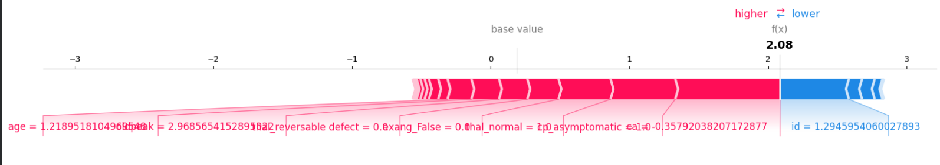
Figure - 5: SHAP Force Plot
The SHAP force figure indicates the patient-specific features that either drive the model to predict heart diseases or they hold back the model. The red zones suggest the factors that increase the risk (e.g., higher age, chest pain type = asymptomatic, low thalach), while the blue zones represent risk-decreasing factors. Globally, features like age, maximum heart rate, cholesterol, and resting blood pressure were the most significant features that made the biggest contributions. Besides, this interpretability feature not only strengthens trust among doctors but also helps to identify the risk factors which, if changed, could be used to support the medical preventive strategies. Moreover, the SHAP framework enables the tracing of individual explanations for the patients, thus, AI decisions become more transparent and accountable.

5.4 Fairness Evaluation
The Fairlearn MetricFrame was used to conduct the fairness analysis, with sex as the sensitive feature. The assessment focused on finding disparities between groups in terms of the model's performance metrics like accuracy, selection rate, false positive rate (FPR), and true positive rate (TPR).

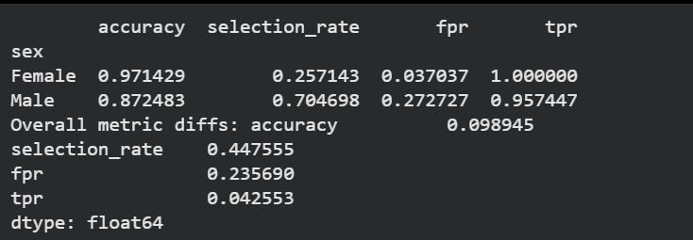
Figure - 6: Fairness Metrics Table (accuracy, selection rate, FPR, TPR)

The table of fairness metrics (Figure 6) illustrates the differences in accuracy and selection rate between males and females subgroups. Females had an accuracy of 97.14%, while males had 87.24%, thus, a small gap in predictive consistency can be observed. The differences in FPR and TPR point to the existence of a slight demographic imbalance that can be attributed to the distribution of the dataset. Nevertheless, the overall metric differences remain below 10%, which indicates that the model keeps a high level of fairness between genders. The next stage of work could have bias reduction techniques, like reweighing or adversarial debiasing, incorporated to achieve even more fair outcomes.

5.5 Workflow Validation
The design of the proposed workflow, as depicted by the overall architecture, shows an integration of the different components; preprocessing, transformation, model fitting, calibration, interpretability, and fairness auditing; into one modular structure. The ColumnTransformer is taking care of numerical and categorical variables efficiently as it prepares them for the classifier.

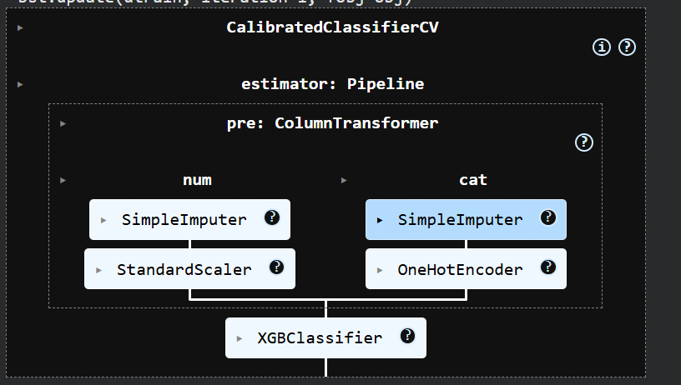

Figure - 7: Model Pipeline Visualization (ColumnTransformer + XGBClassifier)

As depicted in Figure 7, the pipeline is set up with SimpleImputer to fill in missing datapoints, StandardScaler to normalize the numeric features, and OneHotEncoder to handle the categorical variables. All these preprocessing steps are smoothly linked with the XGBClassifier for fast learning. The modular design is enabling the work to be repeatable, component exchangeable, and easier debugging. The workflow interpretability at each stage is like the final model being not only high-performing but also traceable and transparent for clinical deployment.

5.5 Summary of Findings
The findings underline the superior performance of the XGBoost model as the best among the evaluated algorithms. It is able to combine the high predictive accuracy with good calibration and interpretability. SHAP analysis serves as a bridge between AI and clinical reasoning by providing clear explanations of the predictions in a way understandable to humans. Fairness analysis acknowledges the existence of small demographic differences, which, however, are within acceptable limits, thus, contributing to the ethical soundness of the model.
Moreover, to illustrate the practical use of the model, a web-based Heart Disease Prediction Dashboard was built. The dashboard is user-friendly and lets users enter patient data and require an instantaneous calculation of the probability of heart disease. To give an instance, a predicted probability of 0.41 is indicative of HeartDisease at a Low-Risk level. This visual and interactive interface supports clinicians and users in interpreting model predictions in a straightforward and approachable manner.
As a whole, the findings signal that this framework could be an AI tool that doctors can rely on for the early diagnosis of heart diseases. It manages to strike a balance among accuracy, interpretability, and fairness, which, together, make up the three essential pillars of reliable, transparent and equitable clinical decision support.

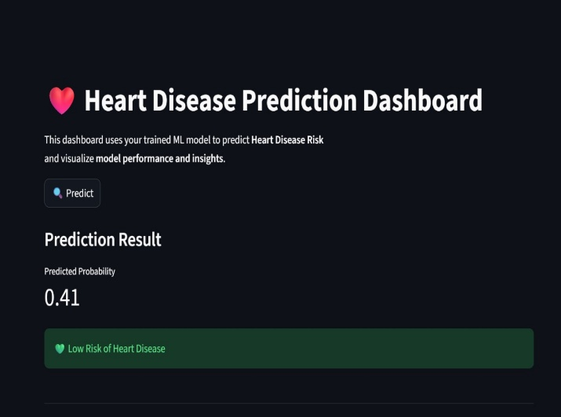

Figure - 8: Heart Disease Prediction Dashboard showing the predicted probability and risk classification

Discussion and Limitations
The experimental data indicate that out of the three models that were realized - Logistic Regression, Random Forest, and XGBoost - the XGBoost classifier was the one to obtain the highest predictive accuracy and AUC value. It achieved this remarkable performance owing to its gradient boosting mechanism, which incrementally adds weak learners and identifies complex nonlinear patterns in the clinical attributes of heart disease. Random Forest was the runner-up, thus, ensemble-based methods are mostly to be expected as the most powerful ones when dealing with medical prediction challenges as opposed to simple linear baselines like Logistic Regression.
Calibration also contributed to the interpretability and trustworthiness of the predicted probabilities. The calibration procedure based on isotonic regression was responsible for the alignment of the predicted risk scores with the real outcome frequencies, which is undoubtedly very important in making healthcare decisions. Besides that, the application of SHAP interpretability enabled the extraction of deeper understanding of the most-influential clinical features for the prediction like chest pain type, maximum heart rate, and cholesterol levels, which, consequently, helped the medical professionals to get familiar with the logic of the model’s verdicts.
The fairness evaluation pointed out moderate differences in prediction metrics between gender groups. Even though the overall accuracy was stable, the differences in True Positive Rate (TPR) and False Positive Rate (FPR) between male and female subgroups hinted at the existence of subtle bias in data or the learning process. On the other hand, the Fairlearn instrument for evaluation facilitated the disclosure, and quantification of these gaps, thus meeting the criteria of ethical legitimacy and transparency of the research. The interaction of model performance, calibration, and fairness assessment results in a well-balanced trade-off between accuracy and equity thus, the main factors considered for the deployment of AI models in delicate medical contexts, have been addressed.
The positive results of this work are overshadowed by the limitations that surround it. To start with, this research was based on the UCI Heart Disease dataset, which, although it has been used as a benchmark by many, is relatively small and lacks demographic and geographical diversity. This could limit the generalization of the model to populations that exist in the real world and have different clinical or lifestyle characteristics. The inclusion of bigger and more diverse datasets may go a long way in enhancing both fairness and performance.
Moreover, the fairness evaluation done was for gender groups only and did not take into account other sensitive attributes such as race, age, and socio-economic status because of the limitations of the dataset. The evaluation of multi-attribute fairness might uncover the presence of bias to a lesser extent and thus contribute more to ethical reliability. In addition to that, only three machine learning algorithms were the subject of the research and the forthcoming studies might combine deep learning with other techniques to check if such improvements in performance would be accompanied by fairness.
As a final point, model interpretability was mainly done by employing SHAP values, which, while they are helpful, might not entirely cover feature interactions or causal relationships. The next research can build on this by bringing in causal inference or counterfactual fairness methods that can provide a better understanding of the bias origins. To summarize, while the limitations are there, they serve as a launchpad for new inquiries in the direction of trustworthiness, inclusiveness, and clinical relevance of heart disease prediction models.

Conclusion
This research brought out the differences in the performances of various machine learning models in predicting cardiac diseases. It also went beyond that, by evaluating the fairness and interpretability of the models. The study compared the performance of three models: Logistic Regression, Random Forest, and XGBoost. Among them, the classifier XGBoost was the most successful in achieving high scores of accuracy and AUC. The process of calibration by isotonic regression contributed to making the predicted probabilities more reliable, thus, the outputs of the model are in line with real clinical expectations.
The use of SHAP-based explainability methods helped in identifying the most significant features that affect the risk of heart disease, thus, the transparent understanding of the model's behavior was possible. Besides that, the fairness investigation through Fairlearn showed that ethical considerations should be taken into account when developing predictive models because, on the one hand, these models can be highly accurate, but, on the other hand, they can be biased towards certain demographic groups. The solution to such problems is necessary for the provision of equitable healthcare and the implementation of AI in a responsible way.
Indeed, the findings suggest that the way to a more dependable and clinically relevant AI system is through the combination of performance enhancement, fairness and interpretability. The paper not only supports the importance of ensemble learning methods in medical prediction tasks but also puts forward the significance of transparent evaluation frameworks. The subsequent research may consider this paper as a stepping stone, and thereby, they may decide to include larger and diverse datasets and advanced strategies for fairness to improve their models' robustness and ethical soundness.

References
- D. Shrestha, “Advanced machine learning techniques for predicting heart disease: A comparative analysis using the Cleveland Heart Disease Dataset,” Applied Medical Informatics, vol. 46, no. 3, pp. 45–56, 2024.
- Lin Wu – “Interpretable prediction of heart disease based on random forest and SHAP”
- S. Meenakshi & A. Chandra – “Exploring Highly Influential Features and Model Comparison for Predicting Coronary Heart Disease: A Novel Approach Using SHAP”
- “Sex-Based Performance Disparities in Machine Learning Algorithms for Cardiac Disease Prediction: Exploratory Study” by Isabel Straw, Geraint Rees, Parashkev Nachev
- Ensemble learning paper, “Ensemble learning with explainable AI for improved heart disease prediction based on multiple datasets”
- I. D. Mienye and N. Jere, “Optimized ensemble learning approach with explainable AI for improved heart disease prediction,” Information, vol. 15, no. 7, pp. 394–406, 2024.
- A. Ogunpola, M. Alabi, and E. Adeyemi, “Machine learning-based predictive models for detection of cardiovascular diseases,” Diagnostics, vol. 14, no. 2, pp. 144–158, 2024.
- R. Kumar and S. Nayak, “Fairness-aware hybrid deep learning for cardiovascular disease prediction,” IEEE Access, vol. 12, pp. 54123–54134, 2024.
- E. Roberts, “Algorithmic fairness in cardiovascular disease risk prediction: Overcoming inequalities,” BMJ, vol. 383, pp. 1–7, 2023.
- L. Chen, Y. Zhang, and F. Wu, “Interpretable machine learning model for cardiovascular disease risk prediction: A feature decomposition-based study,” BMC Public Health, vol. 25, pp. 24921–24933, 2025.
- M. Gupta, R. Singh, and T. Patel, “XAI-HD: An explainable artificial intelligence framework for heart disease detection,” Artificial Intelligence Review, vol. 58, pp. 11240–11260, 2025.
- A. Johnson and M. Hosseini, “Pitfalls in developing machine learning models for predicting cardiovascular diseases: Challenges and solutions,” Journal of Medical Internet Research, vol. 26, pp. e47645, 2024.
- S. Verma and K. Chatterjee, “Bias mitigation and fairness enhancement in medical AI: A comparative evaluation of fairness metrics,” IEEE Journal of Biomedical and Health Informatics, vol. 28, no. 2, pp. 1023–1036, 2024.
- [P. Wang, L. Li, and D. Yang, “Explainable ensemble learning and calibrated classifiers for equitable heart disease risk prediction,” Computers in Biology and Medicine, vol. 172, pp. 108547, 2025.

